URL:.
https://www.drbronner.com/chocolates/what-is-fair-trade-chocolate

HTML Title: What Is Fair Trade Chocolate?

Meta description:
Fair trade chocolate has been made using sustainable and ethical practices from production all the way up to a purchase. Learn more in this comprehensive guide.

Google Preview: Chocolate that is fair trade and organic has been made using sustainable and ethical practices from production all the way up to a purchase.

Breadcrumb:
Fair Trade Chocolate

<h1>What Is Fair Trade Chocolate?</h1>
Intro Summary Paragraph:
Chocolate that is fair trade and organic has been made using sustainable and ethical practices from production all the way up to a purchase. Fair trade produced chocolate ensures farmers are treated fairly and that the farming practices employed aren’t destructive to the environment.

Table of Contents
- What Does Fair Trade Chocolate Mean?
- How Does Fair Trade Chocolate Alleviate Poverty, Child & Slave Labor?
- How Does Fair Trade Improve Environmental Sustainability?
- What Is Fair Trade Certified Chocolate?
- What’s the Difference Between Fair Trade and Direct Trade?
- History of Fair Trade Cocoa & Chocolate
- What to Look for When Buying Fair Trade Chocolate Products
- Helpful Resources
- Further Reading

Chocolate's popularity is nearly unmatched worldwide. Historically, though, its production has led to deforestation, poverty, child and slave labor, and other ethical and environmental issues. Buying fair trade chocolate helps change these practices in a number of positive ways.

H2: What Does Fair Trade Chocolate Mean?

The primary ingredient in chocolate is the cacao bean, which grows mostly in tropical climates located in Latin America, Western Africa, and Asia. For decades, most farmers in these countries were unaware of where their crop was being shipped to or even how valuable it was. Similar to sugarcane, many companies exploited farmers by paying exceptionally low prices [1]. And because of these low prices, resources were spread thin for farmers which led to the use of slave and child labor [2].

H3: How Does Fair Trade Chocolate Alleviate Poverty, Child & Slave Labor?

When it comes to chocolate production, fair trade cocoa guarantees a minimum price for their crop (called a Fair Trade Minimum Price). This acts as a safeguard for farmers by ensuring they will always be compensated fairly even when market prices drop.
Also, a fair trade premium is given to farms. This additional sum of money goes into a fair trade fund, where a committee of farmers, production workers, and other members determine how the funds will be allocated, such as planting new trees or building new facilities.

Being paid fairly combats the need for child and slave labor. Poverty is one of the leading causes of child labor, and providing adequate compensation to farmers is one of the primary ways to end this practice [3]. On top of this, if a group, farm, or organization is certified fair trade, third parties conduct inspections to meet fair trade standards. These third parties work with the farming community to improve any conditions if needed.

H3: How Do Fair Trade and Regenerative Organic Certified Practices Improve Environmental Sustainability?

Fair trade and Regenerative Organic Certifications help promote sustainability in the production of cocoa crops in several ways, including:
- Prohibiting use of GMOs (genetically modified organisms)
- Prohibiting monoculture farming, which depletes soil nutrients, contributes to erosion, and can contaminate water supplies
- Investing in regenerative soil practices [4] and dynamic agroforestry [5]

H2: What Is Fair Trade Certified Chocolate?

A fair trade certified product is one that meets the standards of a third-party state or private organization, such as the World Fair Trade Organization [6]. Typically, the standards can be broken down into three categories:
- Environmental: These standards reduce farming practices that have a negative impact on the planet. They protect natural resources and encourage regenerative actions that are good for the soil and climate.
- Social: These standards prevent child and slave labor, and other exploitative practices from occurring. Safe working conditions, democratic voting (or decision making) are also crucial.
- Economic: These standards establish things like the fair trade minimum price, the premium, and improve the visibility of the product’s journey from beginning to end.

H2: What’s the Difference Between Fair Trade and Direct Trade?

Direct trade is where the producer of a crop works directly with the retailer. While this can improve the relationship between producer and seller, there are no oversight bodies to ensure the product is produced fair and ethically as in the fair trade model. For the most part, direct trade is concerned with reducing the number of layers that exist from production to consumer, which can lead to a higher quality product but lacks the standards that ensure the product was ethically produced.

H2: History of Fair Trade Cocoa & Chocolate

While the fair trade movement more formally took off in the 1990s, its roots extend back several decades [7]. Here’s a condensed timeline of fair trade chocolate:
- 1946: Edna Ruth Byler begins selling crafts from a Puerto Rican sewing group to friends in the US. Her business model sought to uplift and empower marginalized groups. Her ideals gradually began spreading into other industries.
- 1968: Attending countries at the UN discuss ways to decrease import taxes on goods produced by developing countries, called the Generalized System of Preferences (GSP) [8]. These programs intended to avoid preferential treatment between nations, but the results were mixed as several goods and countries weren’t included in the agreement.
- 1988: The Max Havelaar Foundation in the Netherlands becomes the first Fair Trade labeling organization. The goal was to give consumers confidence that the coffee they purchased was ethically produced. As a result, many small farmers saw improved income generation, access to resources, and more.
- 1992: TransFair International and the Fairtrade Foundation are established in Europe. They have different standards and monitoring practices.
- 1997: The Fairtrade Labeling Organizations International (FLO) is established, a collection of 17 fair trade bodies seeking to make a more organized, streamlined process for certifying fair trade practices. The fair trade mark is created to label products that meet a specific criteria.
- 2002: The various fair trade labels are replaced with a standard fair trade mark as an effort to move towards a single, standardized fair trade label
- 2003: FLOCERT is established to better monitor farmers’ operations and record keeping. The organization would later obtain ISO 65 certification to increase credibility of fair trade products.
- 2011: Fair Trade USA resigns from the global fair trade system to pursue its own certification model.
- 2011: In their New Standards Framework, FLO updates their processes and standards to make compliance with certification easier for smaller farms.
- 2020: An annual report from Fairtrade International reports the successful implementation of a 20% increase in the fair trade minimum price for cocoa.

H2: What to Look for When Buying Fair Trade Chocolate Products
Many companies’ claims that their product is ethically sourced are dubious at best. Beware of misleading claims that don’t mean much, a marketing practice known as “greenwashing.” For example, be conscious of words like green, sustainable, clean without any formal seals from a veritable fair trade body. “Fairwashing” can also be present on many chocolate labels, as one or two ingredients could be sourced fairly but the rest are not. Some certifiers let products display a fair trade certified logo with minimal fair trade content. When purchasing chocolate, look for the following labels:

Association for Fair and Sustainable Tourism (ATES)

Biopartenaire

Fair For Life

Fairtrade International

Naturland Fair

Small Producer’s Symbol

World Fair Trade Organization

H2: Frequently Asked Questions
What is fair trade about Dr. Bronner’s chocolate?
Dr. Bronner’s is certified fair trade under the Fair for Life program, which is overseen by the respected international certifier, Ecocert.

“Fair trade” means that the prices paid to farmers, as well as the wages & working conditions of farm & factory workers, are fair. For example, the price we pay cocoa farmers for their cocoa crops is 15% higher than the conventional price. In case of low market prices, at least the fair trade minimum price is paid. This safety net assures that costs of production are always covered, and that the farmer earns an income, and enables them to meet their basic needs, such as good food & accommodation, schooling, the ability to participate in social life, and provisions for times of need.

An additional 10% is paid into a fair trade fund (estimated $80,000 per year, on average) for community development projects in education, healthcare & infrastructure. These are just a few of the many ways we ensure true fair trade partnerships with farmers & workers.

Other ways Dr. Bronner’s helps farmers achieve a higher income:
Farmers receive intensive training and support aimed at improving cocoa productivity and quality, e.g., regarding farm maintenance and renovation of unproductive cocoa crops.
We support farmers in diversifying their farms and marketing additional crops at a fair price. Thus, we enable them to achieve higher and more stable farm income and to improve the level of food security in their communities.
Farmers also receive in-kind support, e.g., provision of planting material, tools, and equipment.
What is regenerative about Dr. Bronner’s chocolate?
Regenerative organic agriculture goes beyond organic practices and aims to improve soil fertility by increasing the humus content of the soil, thus increasing yields and improving the resilience of the soil, as well as its ability to sequester atmospheric carbon. Serendipalm’s farmers use regenerative organic practices such as mulching, cover cropping and mixed cropping.
Since 2020, Serendipalm has been certified to the Regenerative Organic Certified™ (ROC™) standard overseen by the Regenerative Organic Alliance. In addition to regenerative organic agriculture, the ROC standard also ensures fair conditions along the value chain, and safeguards animal welfare.

View other frequently asked questions.

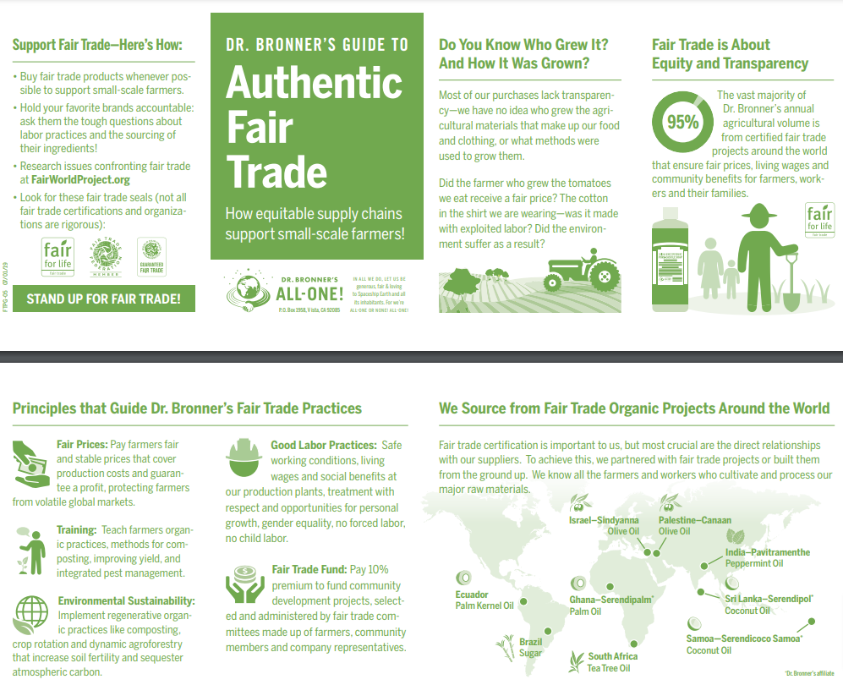H2: Helpful Resources and Additional Reading
- Vegan Fair trade Chocolate - View our Magic All-One Chocolate
- How To Make Chocolate - Learn how Dr. Bronner does it!
- Our journey to making regenerative cocoa
- Dr. Bronner’s Fair Trade Archives
- Fair World Project further reading
  - Chocolate Unwrapped
  - Fair Trade History
  - Child Labor in Cocoa
  - Guide to Fair Trade Labels

Competitor Images

Image File Names:
- fair-trade-chocolate.jpg
- chocolate-fair-trade.jpg
- Chocolate-child-labor.jpg
- Chocolate-slave-free.jpg
- what-is-fair-trade-chocolate.jpg

Image ALT Tags:
- Fair trade chocolate - Dr. Bronner’s
- Chocolate fair trade - Dr. Bronner’s
- Chocolate child labor - Dr. Bronner’s
- Chocolate slave free - Dr. Bronner’s
- What is fair trade chocolate - Dr. Bronner’s

VIDEO:
Competitor Videos

Search in Google with your top keyword phrase, then click on the Google Video Tab results >> that’s your video competition and inspiration for a video to create & add to this page

